**Advanced Dentistry and Innovation**

**Conference & Exhibition**

**Catering**

**2025**

**An International Gathering for dental Practitioners.**

**19th Nov.**

**London**



# **Content**

**Content** 1

**Catering** 2

**Contact Us:** 4

# **Catering**

As you venture beyond the conference premises, we invite you to immerse yourself in the rich tapestry of culinary delights that the surrounding area has to offer. London is renowned for its diverse and eclectic dining scene, boasting an array of eateries ranging from cozy cafes to Michelin-starred restaurants.

While we do not endorse any specific dining establishments, rest assured that you'll find a plethora of options to tantalize your taste buds within walking distance of the conference venue. Alternatively, for added convenience, you can enjoy a meal at the Garrod Building buffet/restaurant located onsite.

For those who prefer to plan their meals in advance, we recommend considering exploring the nearby dining options upon arrival to ensure a seamless dining experience during your visit. Additionally, attendees have the option to enjoy a meal at the buffet restaurant located within the Garrod Building for added convenience. Please keep in mind that while we strive to provide a seamless conference experience, we are not responsible for any arrangements made outside of the event. It's essential to exercise your discretion and explore dining options that align with your preferences and dietary requirements at your convenience.

Additionally, if you prefer to bring your own food, you're more than welcome to do so. We understand that each attendee has unique preferences, and we want to ensure that you have the flexibility to enjoy your meals in the manner that best suits you.

As you embark on your culinary journey, we extend our best wishes for a delightful dining experience. May your culinary explorations be as rewarding as your participation in the conference itself. Bon appétit!

Below is a map showing some local restaurants and buffets.

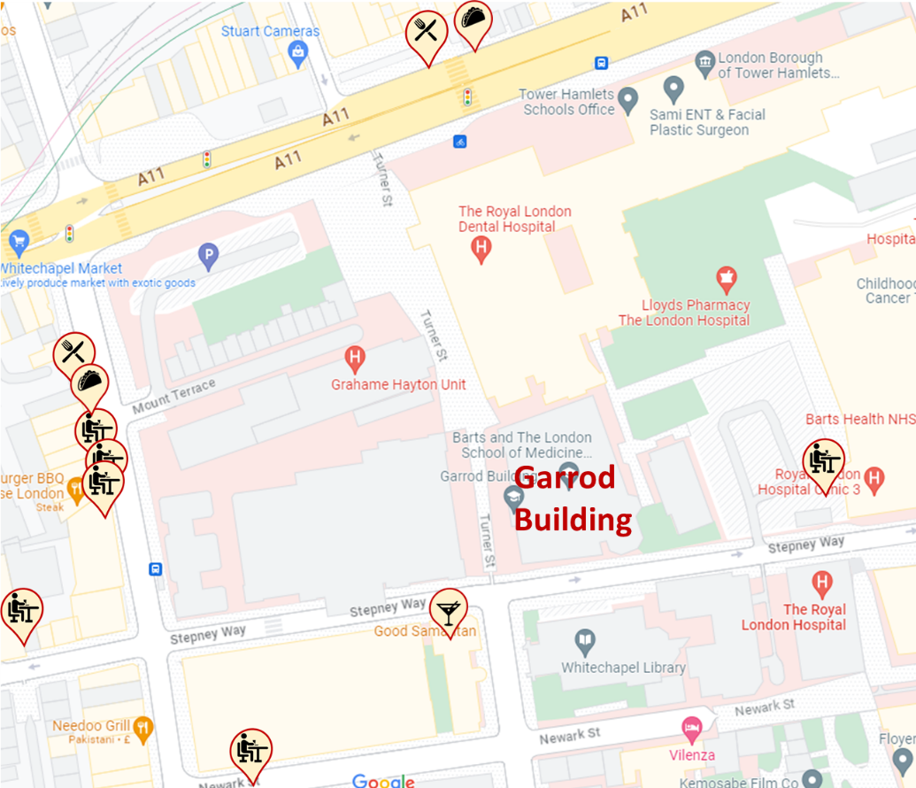

## **Contact Us:**

In case of having any special requirement please send an email to enquiry@ukdentalcourses.com.

Please let us know if you need any help, otherwise you may call us on (+44) 01737 77 34 54

If you face any difficulty or an emergency on the event day, please call on (+44) 077 83 459 110.

